STEEP ANALYSIS
South Africa

South Africa
Intro: South Africa (SA) is located on the southern point on the African continent. SA is divided into 9 provinces, each with their own subset of districts. This country offers some great opportunities for business and investment in many market sectors. Despite the fact that South Africa has recently been experiencing some turbulent times in many areas, there is still potential for growth as the country continues to develop.

Social

In 2018 South Africa has an estimated population of 57.3 million people. This represents a growth of .6 million from the previous year. South Africa’s current demographic makeup consists of: black African 80.2%, white 8.4%, colored 8.8%, Indian/Asian 2.5% The people of South Africa recognize 11 official languages(isiZulu (official) 22.7%, isiXhosa (official) 16%, Afrikaans (official) 13.5%, English (official) 9.6%, Sepedi (official) 9.1%, Setswana (official) 8%, Sesotho (official) 7.6%, Xitsonga (official) 4.5%, siSwati (official) 2.5%, Tshivenda (official) 2.4%, isiNdebele (official) 2.1%, sign language 0.5%, other 1.6%), of which, English is the primary choice for business . Because South Africa has such a variety of diverse populations, languages, and religions, it has become a model for the sub-Saharan African countries to aim for.

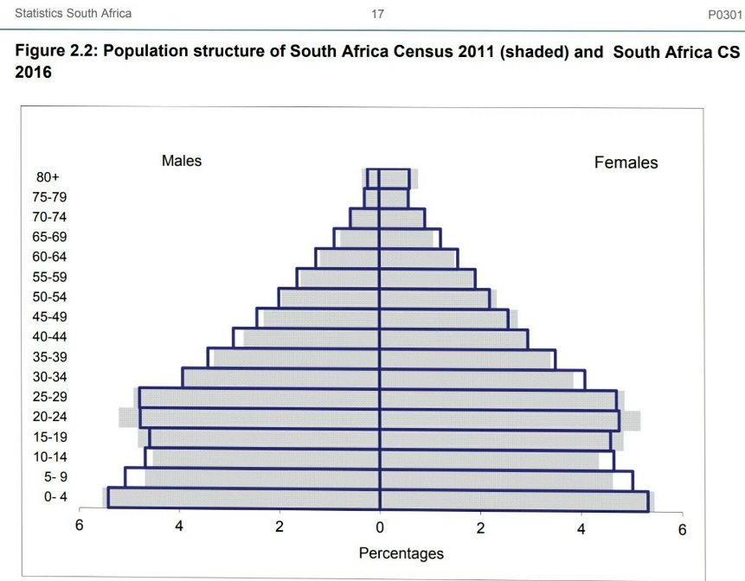

Infant Weight
8.7% of children are underweight . This is a country wide estimation, although, the health of infants varies greatly from province to province. This could potentially mean that there is a need for easier access to nutrition for babies in some provinces.
Infant population
South Africa has a shrinking infant population. Roughly 2.29 children are born per woman. This could be a factor to pay attention too as women are having less children, less baby food is going to be desired.
Infant Mortality rate
Currently the infant mortality rate is averaging 31 deaths per 1000 births. Although this is number is not as high as many developing nations, the infant mortality rate is still is significantly higher than many developed nations.
Literacy Rate
as of 2017 94.4% of the population above the age 15 can read and write. This indicates that the market is open to advertising and marketing of products that use symbols.
According to the social progress imperative (a nonprofit organization that tracks the social progress of countries), South Africa excels in many areas compared to its neighbors in the region. The social progress tracks 3 dimensions of social issues, each with their own subset of components. The Social Progress Imperative defines ‘social progress’ as the capacity of a society to meet the basic human needs of its citizens, establish the building blocks that allow citizens and communities to enhance and sustain the quality of their lives, and create the conditions for all individuals to reach their full potential . South Africa scores average on many dimensions but there are some strong opportunities for business and culture exchange.
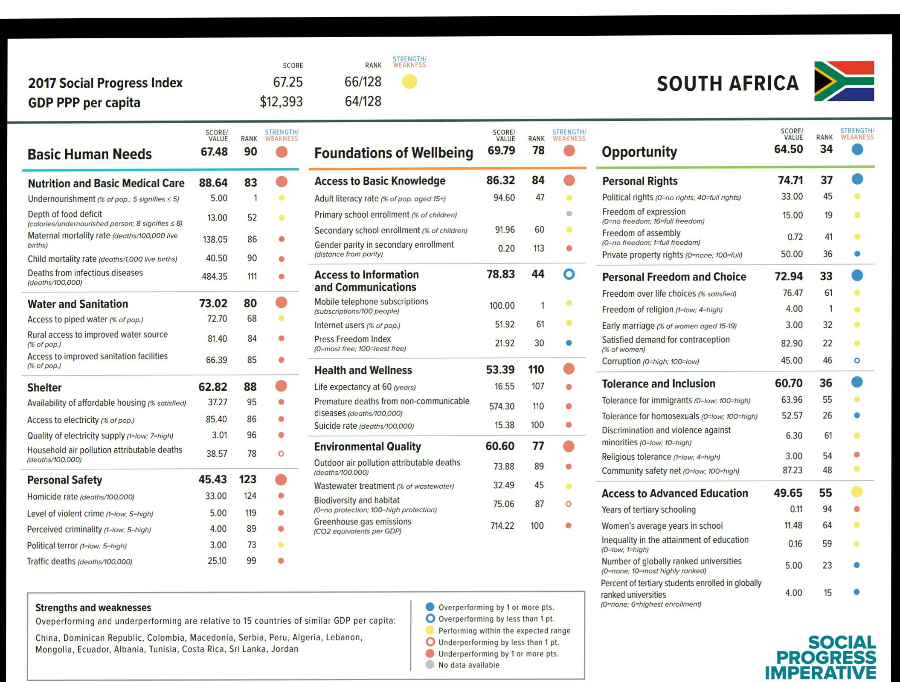

Technology
South Africa is the most technologically advanced nation of the 52 countries in Africa. Roughly, 90% of the South African homes have access to electricity. In addition, South Africa has some of the highest mobile phone penetration on the African continent.
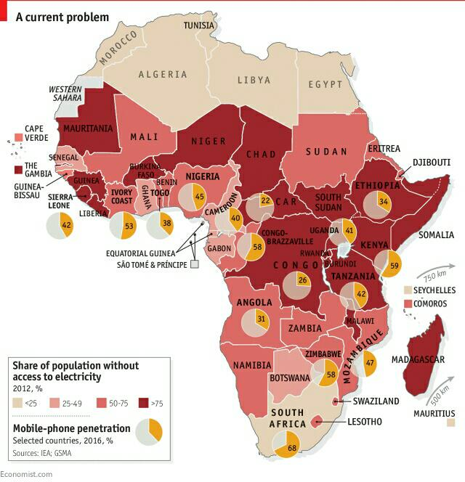

Electricity
Electricity is an essential part of modern life. Roughly 86% of South African homes have access to electricity. New businesses should not have difficulty with access to electricity.

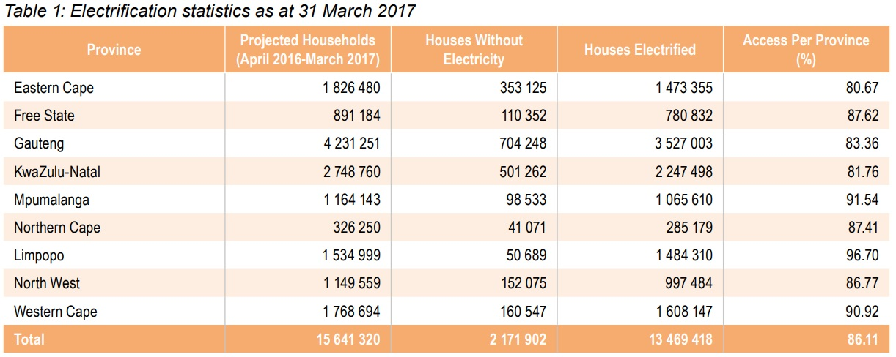

Cell Phones
South African cell phone ownership has been increasing since 2002. As of 2014 it is estimated that 89% of adults in south Africa own a cell phone.

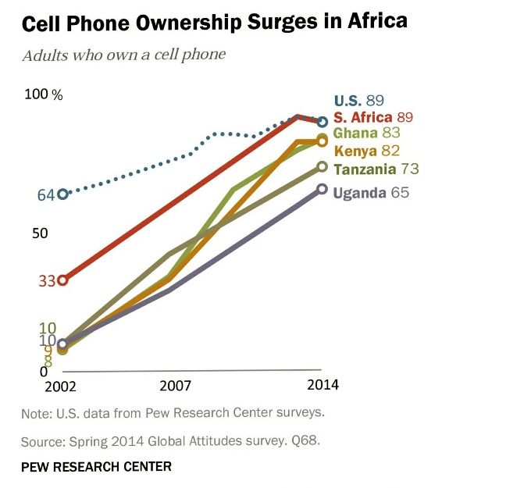

Smart Phone Users
The number of smart phone users has increased. This means that people are having more ease of access to internet and advertisements. It is estimates that by 2022 there will be 25 million smartphone users in South Africa

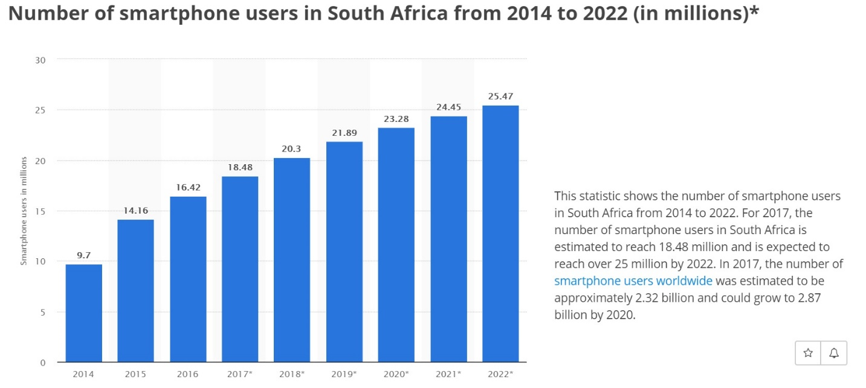

Internet Usage
Regarding internet usage, a report from the world Wide Worx states “The South African Internet user population passed the 20-million mark for the first time in 2016, reaching 21 million, and to 22.5 million in 2017. The report reveals that the single most common use of the Internet among South African adults is communication, reported by almost a third (31 per cent) of respondents, followed by social networking (24.9 per cent) and information (23.7 per cent), both reported by almost a quarter of respondents”.
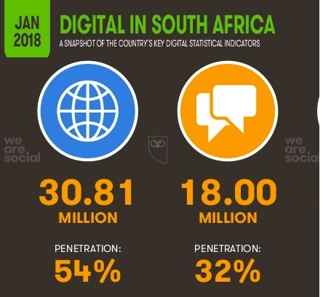

Roads
Data from the South African National Roads Agency Limited (SANRAL) shows that South Africa has 746978km of road network. 158124km is paved and operated by SANRAL. The rest of the road network is divided amongst the 9 provinces.

The two pictures below are from a 2017 SANRAL Annual report We can see the massive network of road accessibility and the pavement condition is well maintained. This is a great strength and opportunity for logistics.
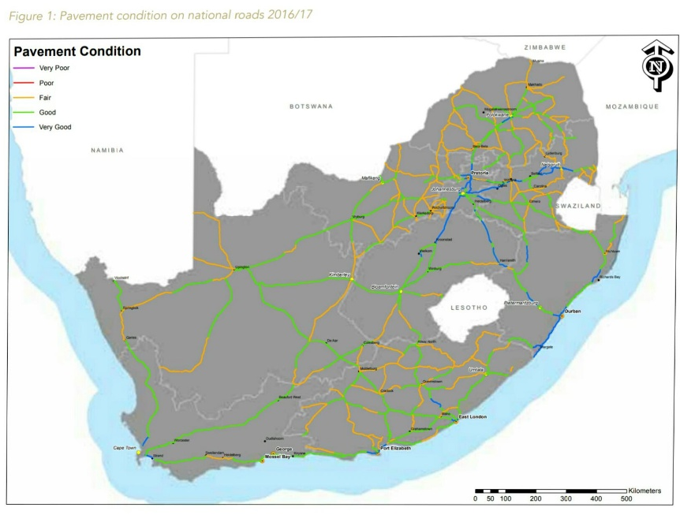
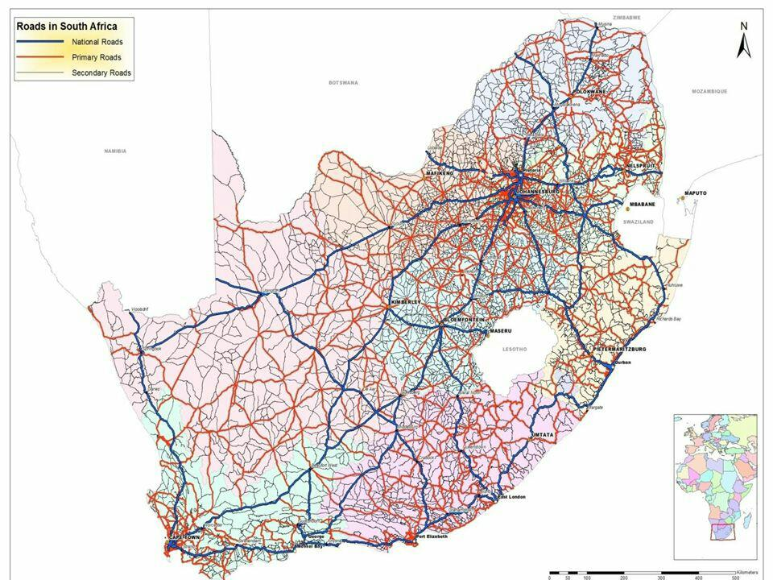
Economic

According to the University of Stellenbosch “South Africa has a distinct dual economy. The first economy is globally positioned, and needs very little support from the government. The second economy, on the other hand, has very few or no formal structures in place and is predominantly a cash-based economy, serving mainly the poorest of the poor”.
Employment
The Employment rate in South Africa has been fluctuating since 2012. In 2017 the unemployment rate has reached its highest levels in recent years.
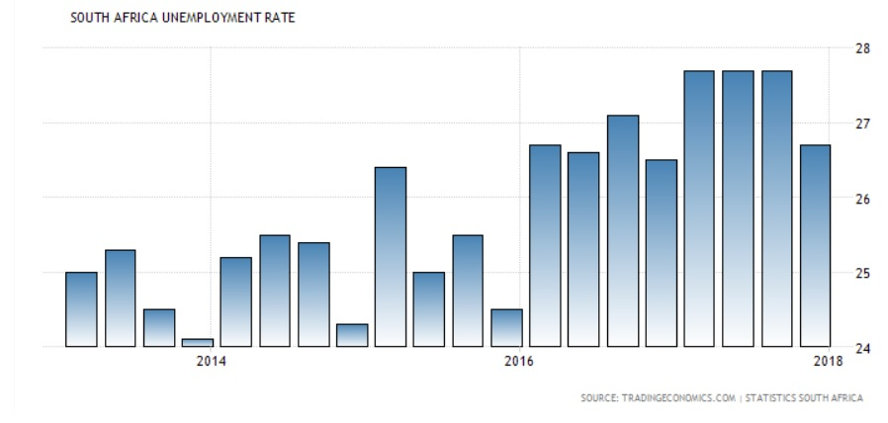

Imports
Between 2008 and 2016 South Africa imported roughly $6B worth of vegetables and foodstuffs. This could be a good indication that the market is in need for food that contain these kinds of vegetables and foodstuffs.
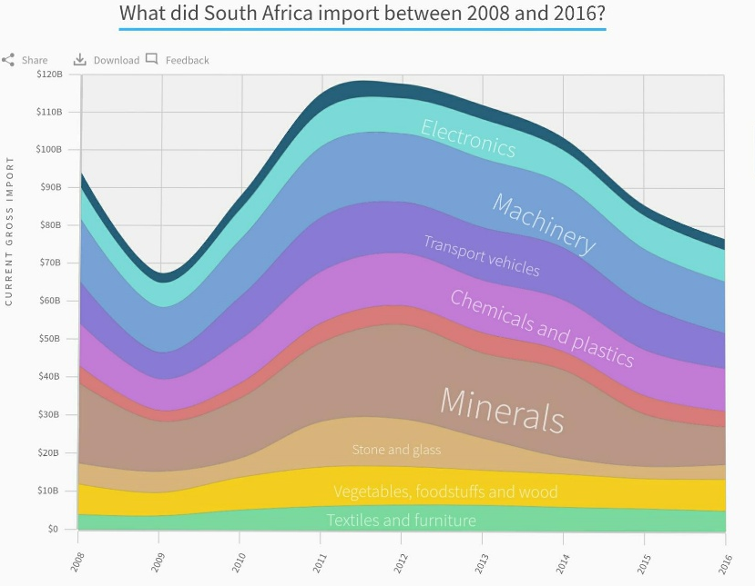

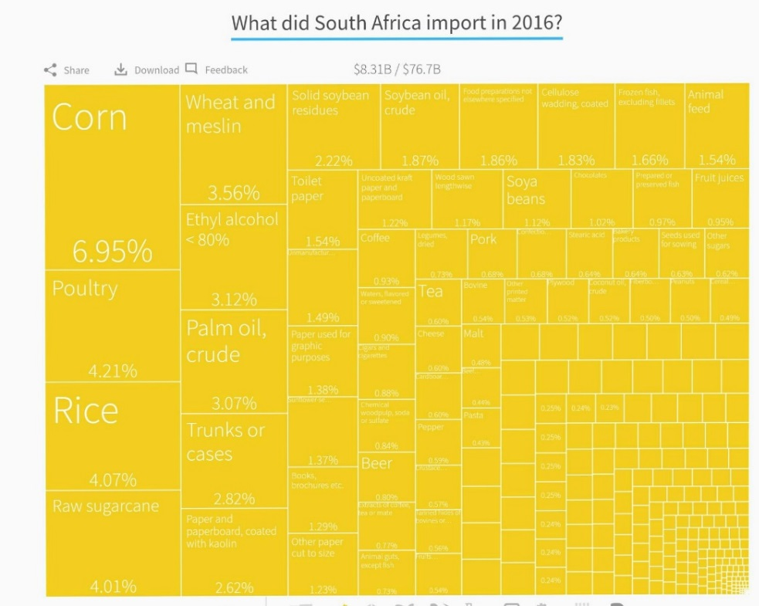

Gross Domestic Product
The GDP of South Africa has been had fluctuating percent changes over the past few decades. However, in recent years there has been positive, increasing GDP levels since 2015. The graph below anticipates a relatively stable but growing economy in south Africa.

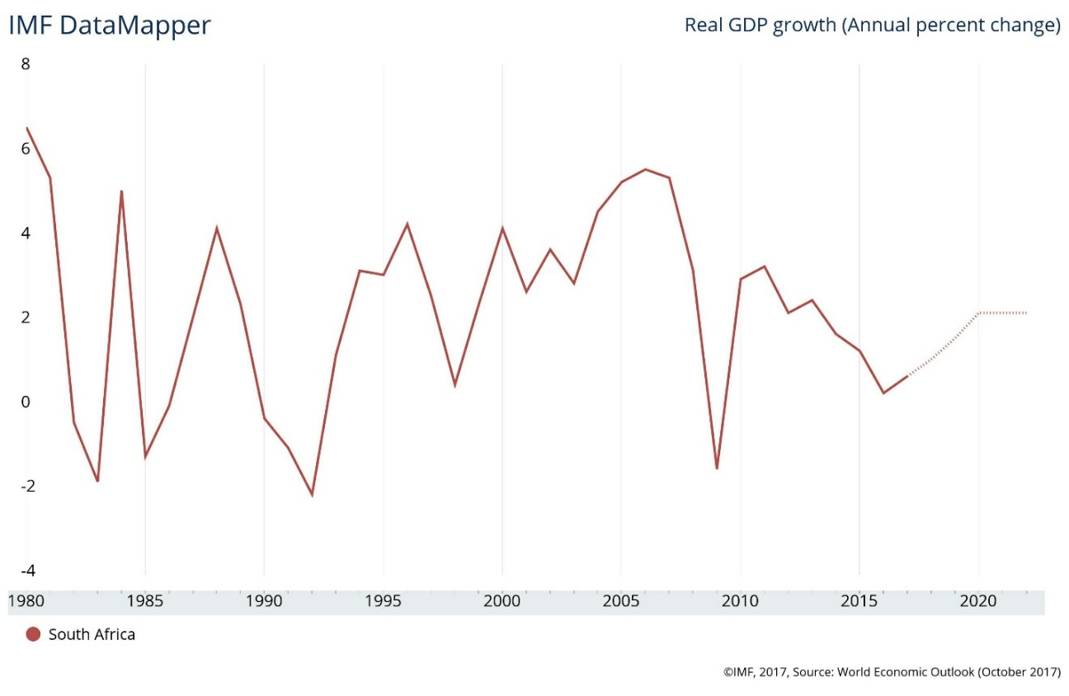

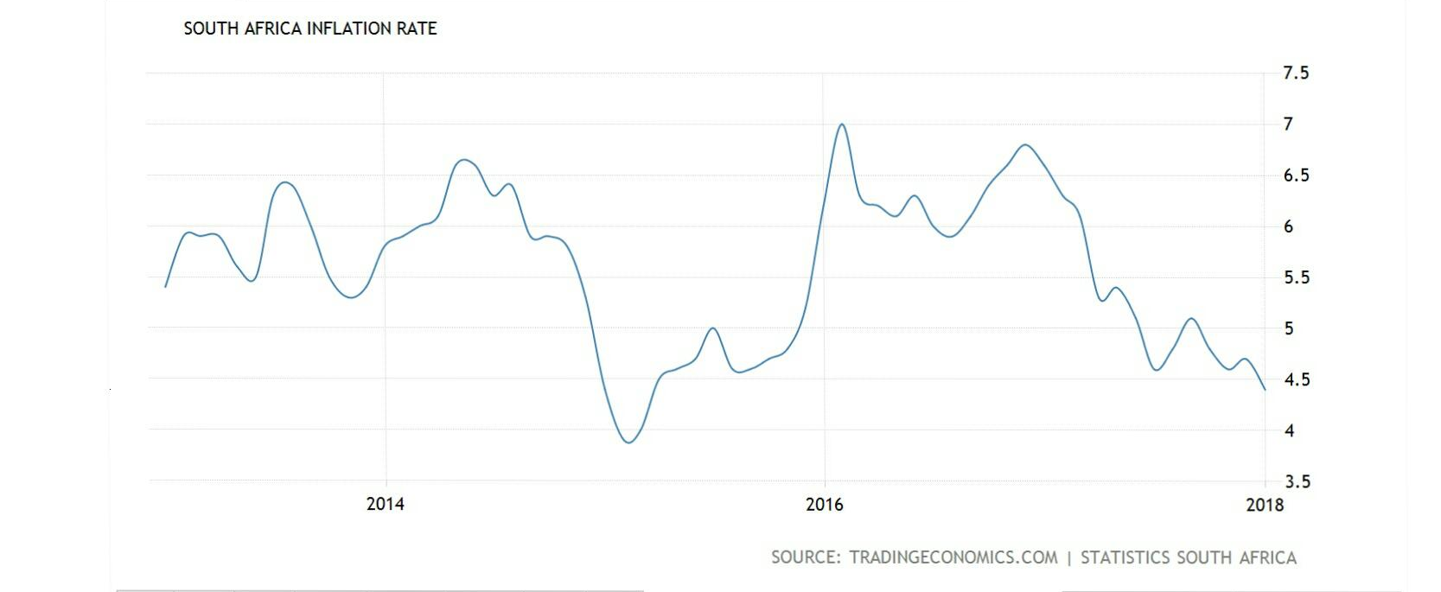
Inflation
In recent years South Africa has experienced a slowdown of the inflation rate. With an inflation rate that is less volatile, this might be a prime moment for market penetration.

Ecological
As the world continues to battle with the effects of climate change, South Africa is one country that is continually bearing the brunt end of the negative side effects. According to the Council for Scientific and Industrial Research, an African research and development organization: “South Africa is facing an increased frequency of extreme weather events such as droughts, dry spells, heat waves and severe thunderstorms. These have the potential to increase vector-borne diseases and lead to food, energy and water insecurity, which will consequently threaten livelihoods”. One of the biggest issues for South Africa right now is the growing concern about water shortages. Over the past decade, South Africa has been the victim of consistent yearly droughts that has left the country parched. The graph below shows the reduction in stored water in Major South African dams.
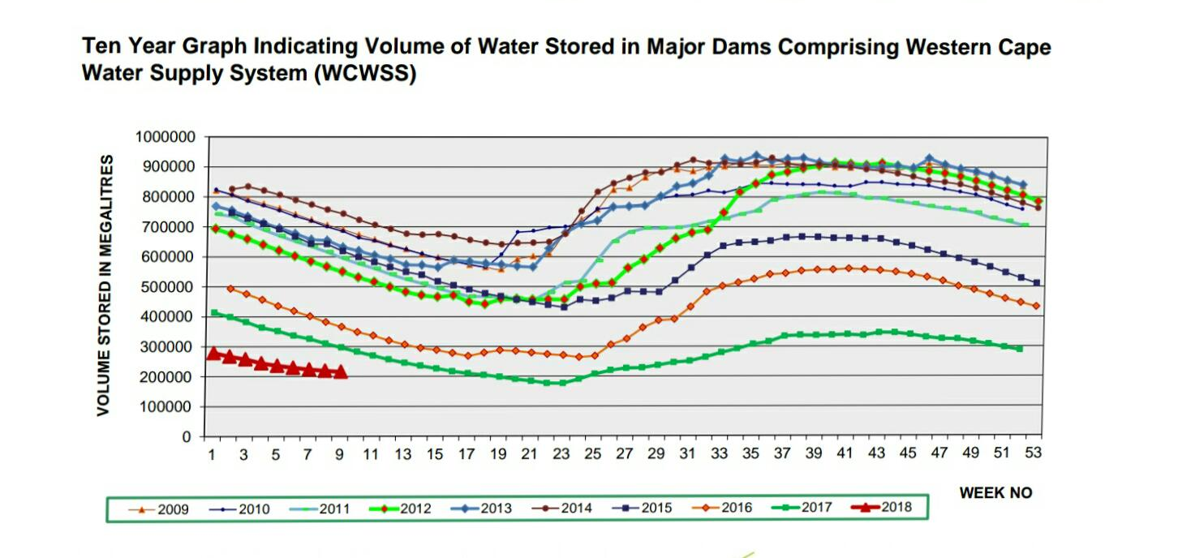

The shortage of rainfall has caused the extremely low levels of water storage inside the dams. These levels are no longer sustainable for populations in major cities. Cape Town in particular is awaiting the dreaded “Day Zero”, the day that the municipality will have no choice but to turn off the taps for local residents. If nothing changes, it is expected that day zero ill come sometime in July 2018. If nothing changes, in climate or in policy, day zero will require residents to queue in line for daily water rations of about six and half gallons. The graph below shows the current trajectory of the water supply system in the Western Cape.

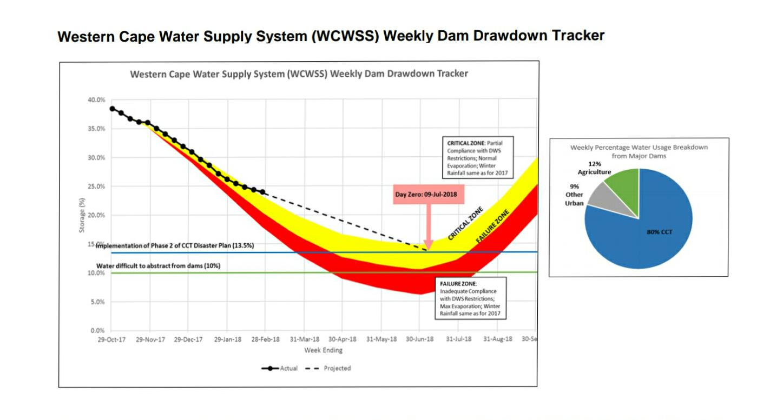

Water is an essential human need and humans are essential for business. If day zero becomes a reality, local businesses will face severe water restriction impositions. Cliffe Dekker Hofmeyr is a law firm in South Africa that has stated their concerns about local how the water crisis will affect local businesses and employment contracts. “Assuming Day Zero arrives, some businesses may not have any access to municipal water. This may make their businesses’ continued operations impossible…the duty of an employer to pay remuneration continues as long as the employee tenders his or her services…An employer would have to pay its employees that tender to work even if it cannot provide them with any work”.
The current water crisis in certain municipalities will be a monumental threat to the business environment. It would be best to monitor the situation and potential select alternative entry locations.

Political/Legal
South Africa has ended its apartheid in 1991 and since then has adopted a representative democracy. This peaceful transition is truly a remarkable accomplishment for the country’s society. The ANC or African National congress has been governing policy agenda since 1994.
Corruption
South Africa’s corruption has been getting worse since 2008. This is partly because more funds are being syphoned from the public sector for the public good, to the private sector for private interests. The graph below represents data from transparency international showing South Africa’s corruption over the past 10 years.
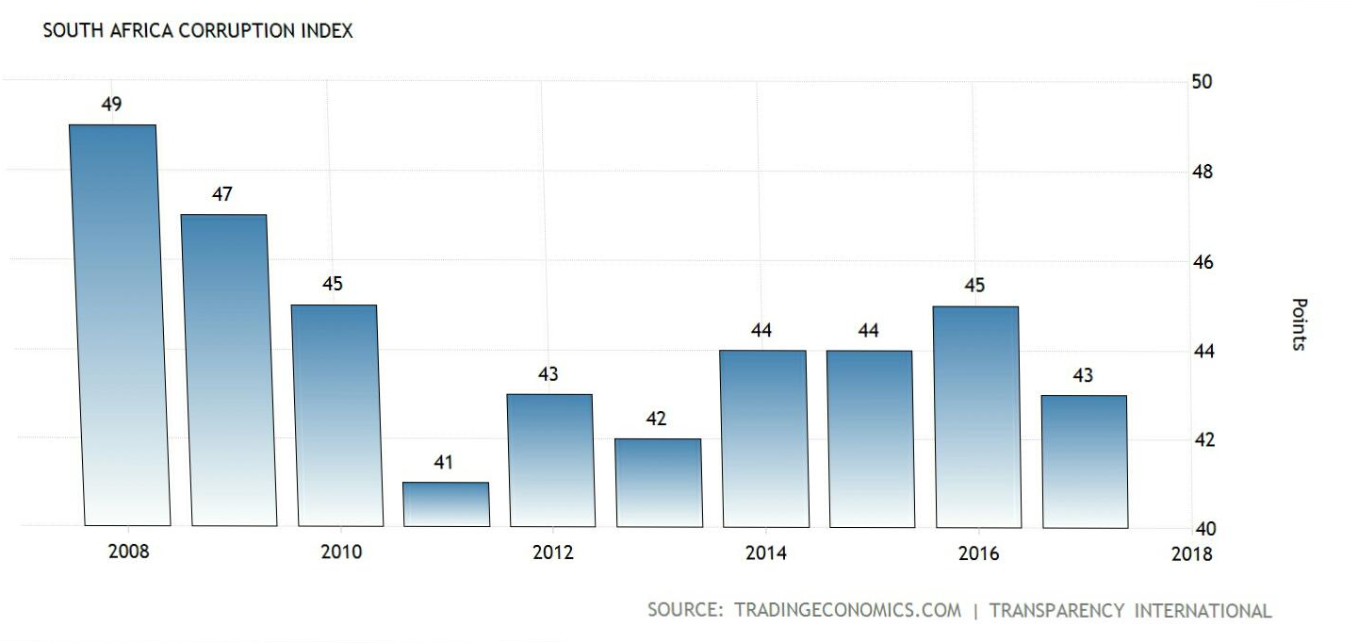

South Africa’s corruption problem has slowly been getting worse as the years progress. The most obvious corruption issues in South Africa come from governmental corruption, state capture and job losses. Many South African’s attribute the current upsurge in corruption to the administration under Jacob Zuma. Mr. Zuma started his role as president in 2009 and it lasted until his recent resignation in February 2018.
As of 2018 South Africa ranks 71st out of 180 countries measured. According the survey from transparency international: The least corrupted country is New Zealand and the most corrupt country is Somalia. Although South Africa is not the most corrupt country in Africa, it maintains its corruption score in the low forties.
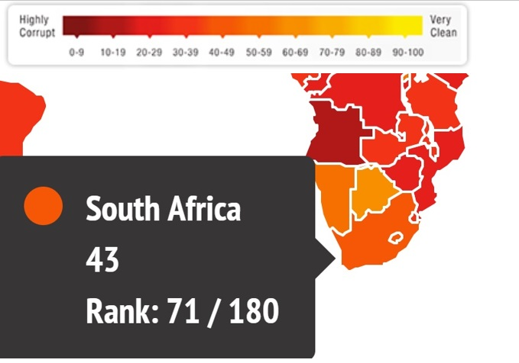

Corruption can have a detrimental impact on businesses in many ways. The rule of law is seriously questioned when a country scores high on corruption perception indexes. Lack of trust and security within a corrupt country can cause investors to be hesitant in supporting new companies. In addition, profits can be slow and unpredictable in in highly corrupt governments.
Fortunately, South Africa is now under a new administration that promises a dramatic shift in policies regarding corruption. Immediately upon taking the role of president, Cyril Ramaphosa vowed to tackle endemic corruption by saying “Issues to do with corruption, issues of how we can straighten out our state-owned enterprises and how we deal with ‘state capture’ are issues that are on our radar screen,”. This looks to be a positive light shining on the prospects of opportunity in South Africa.

Entry Strategy
(Part Two)
South Africa

Exporting Strategy
For the product’s four year forecast I suggest the best entry strategy would be to export the product to South Africa. By choosing this entry strategy, we would effectively eliminate unpredictable risk but not directly penetrating the market with FDI. The Eastern Cape in South Africa is the perfect location for market entry and exporting.
The Eastern Cape is located on the south eastern side of South Africa. The market potential in this province offers some great opportunities for success. The Eastern Cape features a convenient port for maritime shipping that provides various freight companies for our cargo.
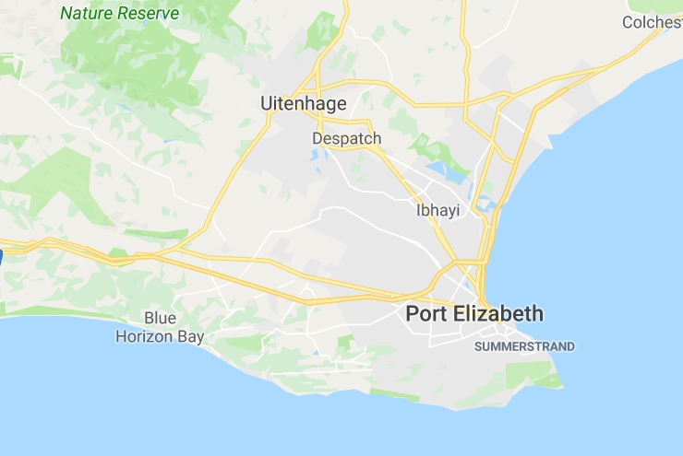
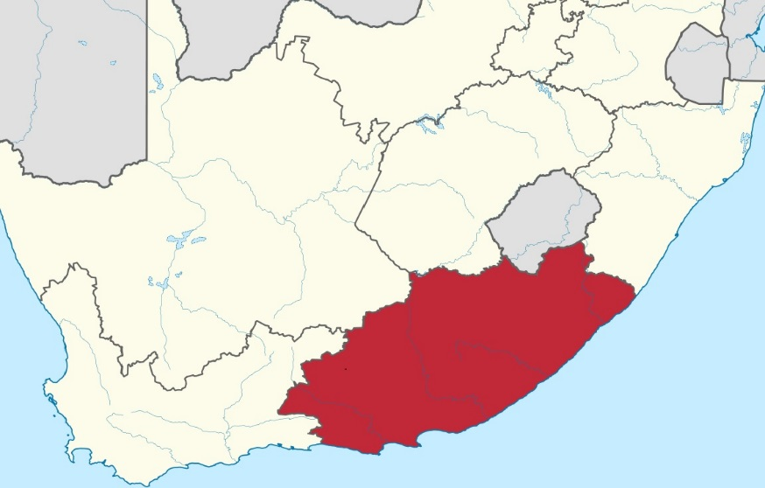

Export From
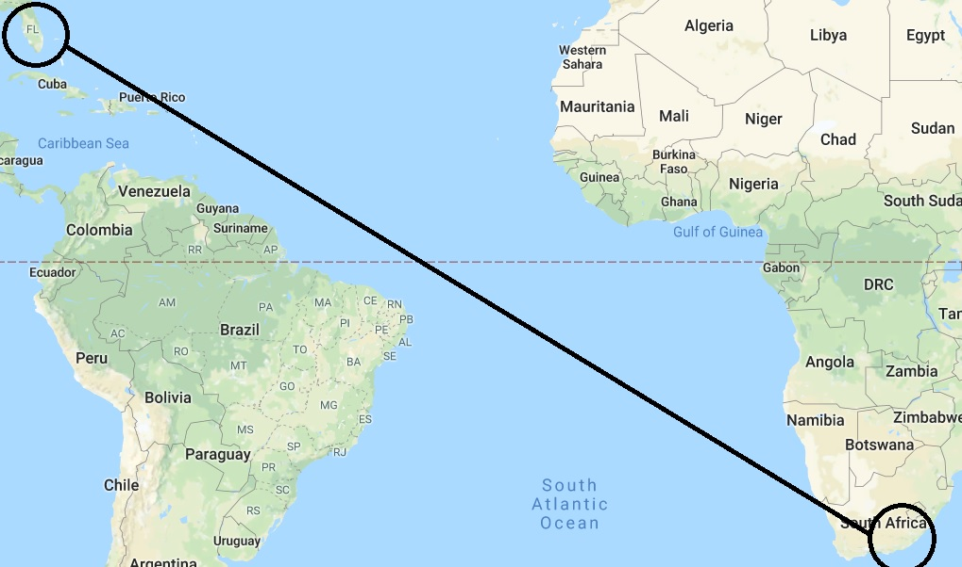
Florida is going to be the best option for shipping our product internationally to South Africa. The Jacksonville Port Authority owns three cargo facilities and generates over $27B in economic activity. This sea port has various shipping companies that offer a wide variety of services and prices.

Target Market
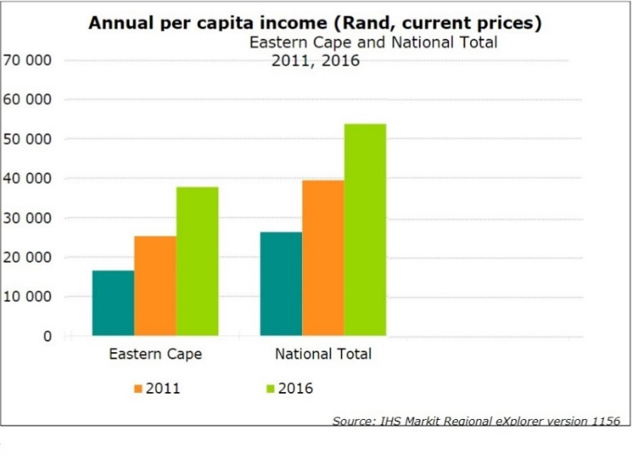
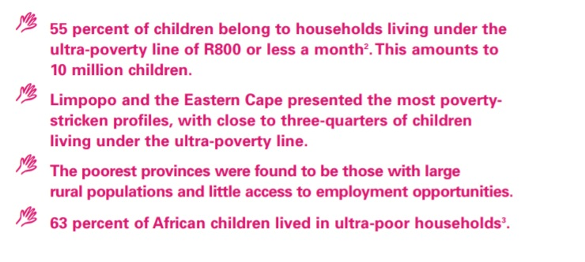
The Eastern cape has a population that is in direct need of low cost infant nutrition. The eastern Cape is one of south Africa’s poorest regions. The Eastern cape is in desperate need of an affordable alternative to infant nutrition. Our product will find itself needed from a spectrum of economic potential. Over the next four years, our product will have plenty of time to develop and adapt to a growing demand for infant nutrition.
Distributors
Fortunately, there are local supermarkets that already feature a variety of infant foods that demonstrates a need for the product. ShopRite, Checker, and Spar are the region’s most popular supermarkets that would provide a great opportunity for our product to gain awareness.

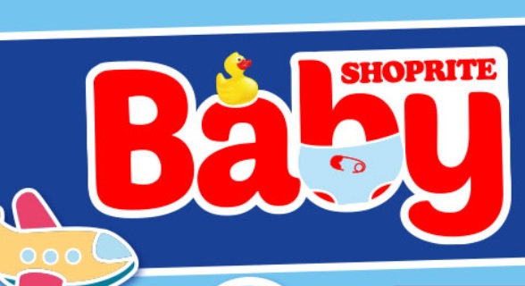
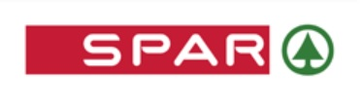
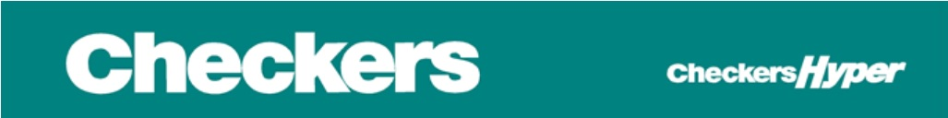
Product Marketing
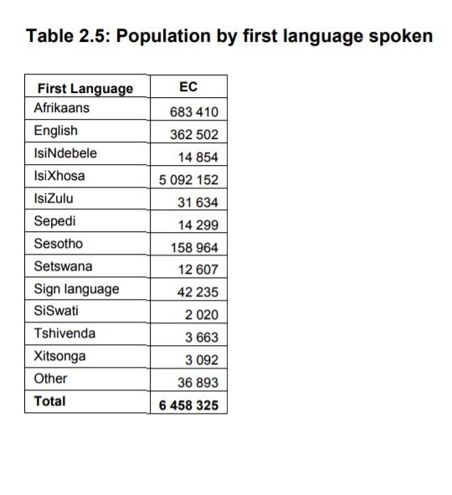
Because of the diverse languages spoken in this region of South Africa, it is recommended that the product details be listed in the region’s most spoken languages. This is IsiXhosa, Afrikaans, English, and Sesotho. This will allow for the majority of potential customers to be able to understand our product contents.

Tariffs
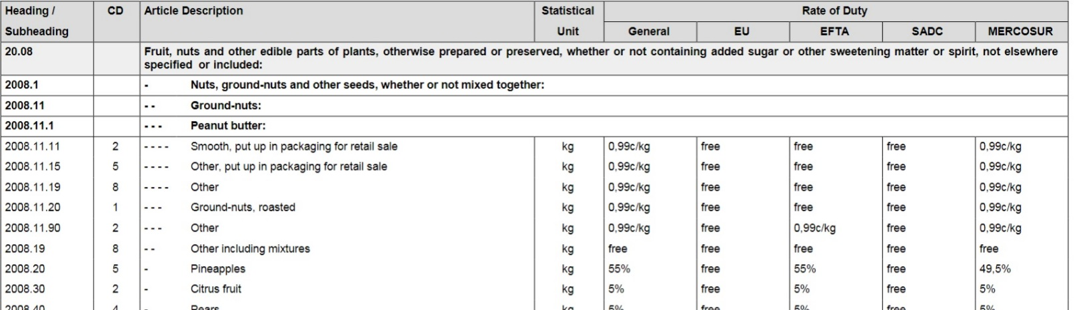
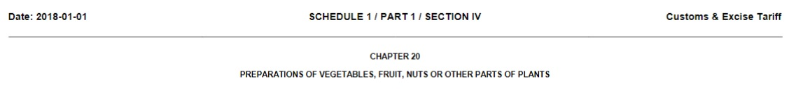
Our infant food will be listed in chapter 19, 20, and 21 in the uniform tariff codes. Below is a sample of how South Africa will codify products coming from the United States. Our products will typically be charged per kilogram this may have an effect on our pricing strategy

Works Cited
5 ground breaking inventions in technology. (2017, March 05). Retrieved from https://answersafrica.com/african-inventions.html
Africa, D. F. (n.d.). SA Internet penetration to reach 40% in 2017. Retrieved from http://www.dfafrica.co.za/press/2017-07-19
Agency, S. A. (2018, January 15). 2017 annual report. Retrieved from http://www.nra.co.za/live/content.php?Session_ID=a5f545765ef1c9e3cfc8979b5c216da1&Category_ID=72
Bank, W. (n.d.). The World Bank In South Africa. Retrieved from World Bank: http://www.worldbank.org/en/country/southafrica/overview
Biekpe, P. N. (2014, May 16). inequality and the dual economy. Retrieved from University of Stellenbosch: http://www.usb.ac.za/thoughtprint/Thoughprint%20Publications%20%20Downloads/Inequality%20and%20the%20dual%20economy.pdf
Burke, J. (2018, february 15). Ramaphosa vows anti-corruption drive as he takes over in South Africa. Retrieved from The Guardian: https://www.theguardian.com/world/2018/feb/15/cyril-ramaphosa-to-be-elected-president-of-south-africa-jacob-zuma
Demographics. (2018, Febuary 02). Retrieved 2018, from Statistics South Africa: http://www.statssa.gov.za/?page_id=1854&PPN=P0302
Energy, D. o. (2017, December 2017). Annual report. Retrieved from http://www.energy.gov.za/files/Annual%20Reports/DoE-Annual-Report-2016-17.pdf
Imperative, S. P. (2017, December 25). See The Worl Differently. Retrieved Febraury 25, 2018, from http://www.socialprogressimperative.org/
Research, C. f. (n.d.). ATLAS TO HELP SOUTH AFRICA’S SECTORS RESPOND TO CLIMATE CHANGE. Retrieved from Council for Scientific and Industrial Research: https://www.csir.co.za/atlas-help-south-africa’s-sectors-respond-climate-change
Simoes, A. (n.d.). South Africa. Retrieved from The observatory for ecoenomic complexity: (https://atlas.media.mit.edu/en/profile/country/zaf/#Imports

http://www.statssa.gov.za/?page_id=1854&PPN=P0302
2 http://www.statssa.gov.za/?page_id=1854&PPN=P0302
http://www.socialprogressimperative.org/
https://answersafrica.com
http://www.statssa.gov.za/?page_id=1854&PPN=P0318
http://www.energy.gov.za/files/Annual%20Reports/DoE-Annual-Report-2016-17.pdf
http://www.dfafrica.co.za/press/2017-07-19
http://www.nra.co.za/live/content.php?Session_ID=a5f545765ef1c9e3cfc8979b5c216da1&Category_ID=72
http://www.usb.ac.za/thoughtprint/Thoughprint%20Publications%20%20Downloads/Inequality%20and%20the%20dual%20economy.pdf
(https://atlas.media.mit.edu/en/profile/country/zaf/#Imports
https://www.csir.co.za/atlas-help-south-africa’s-sectors-respond-climate-change
https://businesstech.co.za/news/business/228209/how-cape-towns-water-crisis-could-affect-salaries/
http://www.worldbank.org/en/country/southafrica/overview
https://www.transparency.org/country/ZAF
https://www.theguardian.com/world/2018/feb/15/cyril-ramaphosa-to-be-elected-president-of-south-africa-jacob-zuma

